Family Birthday Celebrations: April 10, 2022

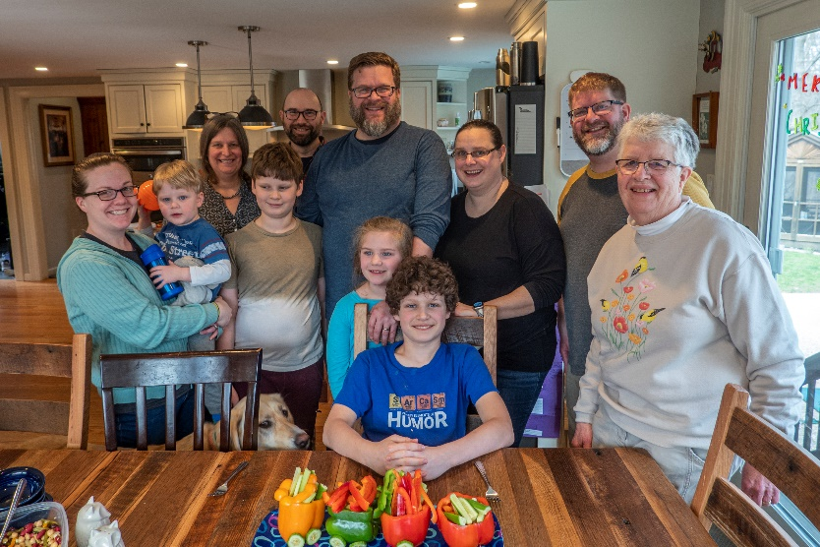On April 10, the family gathered at Dave’s in Stow, MA, to celebrate Greyson, Steve, and Dave’s birthdays. We arrived a day earlier and enjoyed watching Greyson’s first 2022 soccer game starting the new season with a 1-0 win!

We are fortunate in that all four families live reasonably close for opportunities like this to be enjoyed. The photo to the right presents Greyson in front of his birthday veggie train with his Dad, Dave, behind him, and uncle Steve behind grandma Phinie.   
  
And for the photos, click on [birthdays -April 2022](https://photos.app.goo.gl/YQtquGHS7g8JTE9o7). Feel free to “zoom”.